NSA Meeting Attendance Log Student Name: Harper Skaare
  - Attendance at 2 NSA meetings (unless excused) is required each semester during semester 3, 4, 5, 6, 7, and 8.
  - NOTE: If your semester fell during summer semester, you are excused but must obtain a signature from one of the NSA advisors.
DATE | Briefly describe what was discussed at the meeting | Photo Upload or  NSA Advisor Signature
SEMESTER 3  N/A | Summer Semester
SEMESTER 3  N/A | Summer Semester
SEMESTER 4  10/21/25 | Challenge of the Quarters, NSAND convention, new open door for nursing students. Pie eating & mummy wrapping contest! | 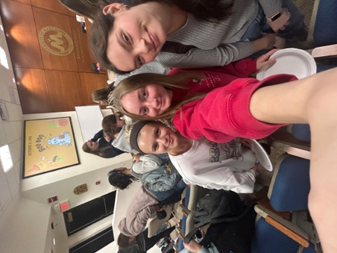
SEMESTER 4  11/18/25 | Check-in on Challenge of the Quarters, SNOY finalists announcement. Upcoming blood drives! | 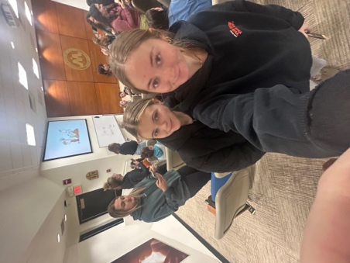
SEMESTER 5  2/17/26 | NSAND board recognition! Nominations for new NSA board. Sandwich making! | 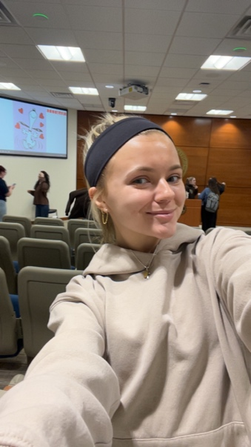
SEMESTER 5  4/9/26 | Will attend & update afterwards!
SEMESTER 6
SEMESTER 6
SEMESTER 7
SEMESTER 7
SEMESTER 8
SEMESTER 8

